1.Read data from two excel and load into one SQL DB table.Already attached two excel file.

Transformation will use:  
1. Sort Transformation  
2. Data Conversion Transformation  
3. Merge Transformation

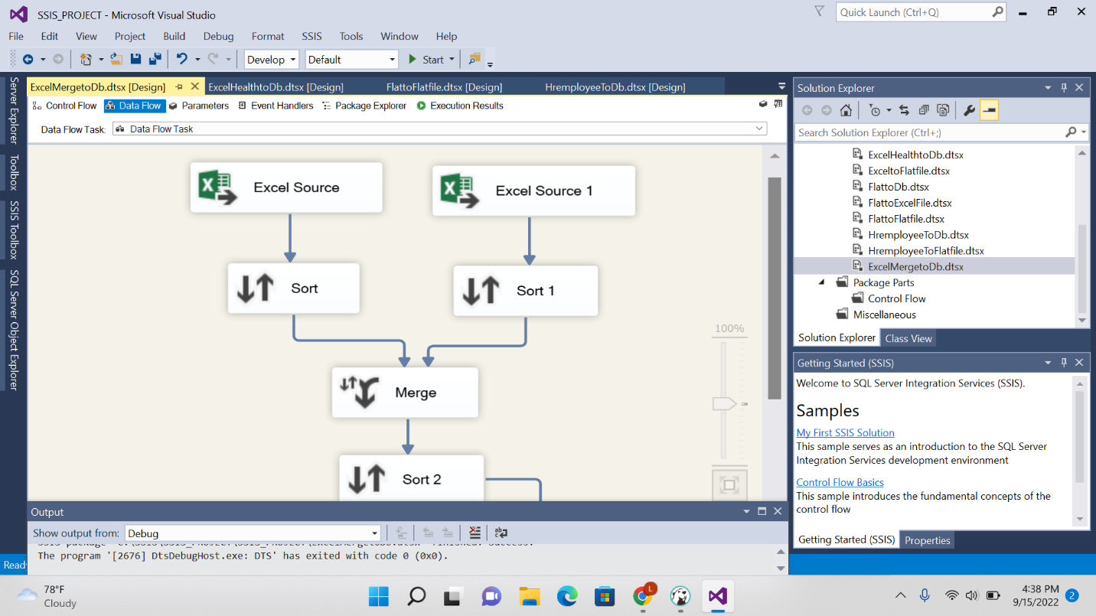

2.Read data from two SQL DB and load into one SQL DB table.  
      ->Create two table with same columns & data type for source  
      ->Create one Target Table for Destination

